**Formative Assignment 1**

|  |  |
| --- | --- |
| Module Name | WSQ Database Design and Implementation (SF) |
| Course Name | Postgraduate Diploma in Software Engineering |
| Assignment Title | Database Design |

|  |  |
| --- | --- |
| Learner Name | Huynh Minh Phu |

|  |
| --- |
| Learner declaration |
| I certify that the work submitted for this assignment is my own and research sources are fully acknowledged.  Learner signature: Phu Date: 15/12/2023 |

## Purpose of this assignment

To demonstrate your capabilities in the following areas:

* Analysis of the requirements
* Design the database for the given scenario
* Build the conceptual design and ER Diagram
* Normalise data into 3rd Normal Form

## Submission Format

The submission is in the form of an individual written report with examples and illustrations. This should be written in a concise, formal academic style using single spacing and font size 12.You are required to make use of headings, paragraphs, and subsections as appropriate, and all work must be supported with research and referenced using the Harvard referencing system. Please also provide a bibliography using the Harvard referencing system.

## Submission file

Submission File Name format: CohortCode_FullName_AssignmentNumber

E.g.: PGSE-DDI-0823_AliceTan_A1.docx

## Scenario

You currently work as a Data Engineer for Brightica design agency, where you design and implement data models for client-centric products. As part of the role, your manager Mr. Andrew assigned the project to develop an optimal database design to deliver Rich Internet Application for Boutiqa. Boutiqa is a marketplace for sellers to promote their products and for consumers to purchase with ease. The company wants to have a consumer-centric application with an enhanced user experience.

You are required to demonstrate your capabilities in the following areas:

* Planning of database use group
* Conceptual, Logical, and Physical design of the database
* Writing queries and stored procedures to optimize the system performance and management reports.

The scope of the project in this module is to design and develop and implement the database. The overview of the project is as below:

There are 3 types of users:

1. Sellers
2. Consumers
3. Administrator

Sellers should be able to perform following functions in the portal:

1. Register in the portal.
2. Update their Profile after logging in.
3. Maintain the product catalog to promote their products.

Consumers should be able to perform following functions in the portal:

1. Register in the portal.
2. Update their Profile after logging in.
3. Search products.
4. Choose products to view the details.
5. Add, edit, and remove items in the shopping cart.

Administrator should be able to perform following functions in the portal:

1. Administer user data.
2. Send bulk email invite to potential clients to register.

You will be required to:

* Identify the entities and their respective attributes for the given scenario
* Add sample data for all the entities
* Normalise the sample data
* Develop a conceptual design
* Create an ER Diagram for the application

## Evidence to exhibit

* List of entities with description

|  |  |
| --- | --- |
| **Entity Name** | **Attributes (what it contains)** |
| Product | * Name * Price * Description * origin * colors |
| Profile | * Name * Date of birth * Phone * Email * Address |
| Portal_user | * Type: role of user (admin, seller, consumer) * Create date * Username * password |
| Catalog | * name |
| Order Item | * amount * note * order date |
| Cart | * cart info |

* Screenshots of normalised data
  + Product

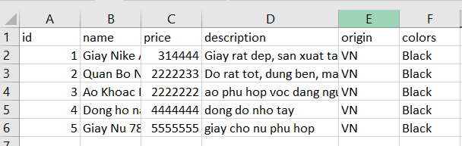

* + Catalog

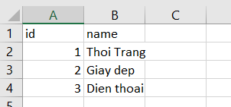

* + Profile

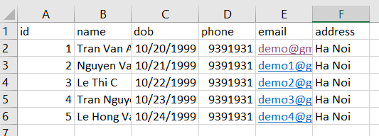

* + Order Item

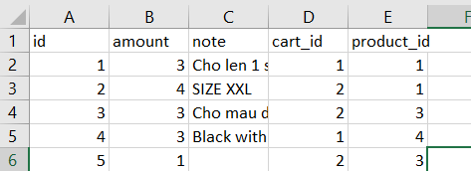

* Screenshot of conceptual design

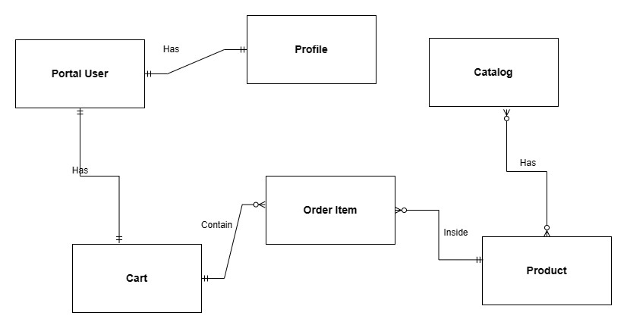

* Screenshot of ER Diagram
* 